Summary for pre-read

WBR - Summary (for Pre-Read)
1) Commercial
Sales Forecast: April FC at 53% (with upside to 55%). Continuation of hostilities resulting in more downside, increased churn and challenging upside. Concerns around cashflow remain top of client minds. Mitigation: March Relief in action; Eid Relief packages announced and in action with 79% of volume (~75% of value) of book in active conversations; Anti-crisis broker playbook shared with BC.
Net Exclusive Listings: Data unavailable this week (compliance checks run on Wednesday and Thursday; exclusive listings data to be added on Friday).
2) Demand
SoS: Overall SoS at 53.4% (-0.5pp vs 53.9% target, +0.8pp WoW). App SoS at 58.0% (+2.1pp above 55.9% target, +0.6pp WoW). Web SoS at 46.1% (-3.9pp vs 50% target, +0.9pp WoW). App SoS continues above target; Web SoS recovering but still below target.
Exposure LPL: Both segments remain below target.
3) Data Governance
Three open items under monitoring: (1) App: Kochava vs Redshift attribution discrepancy (2) Web: GA4 vs Redshift data reconciliation (3) CRM Attribution Reporting
4) New Projects (Primary)
New Projects gross revenue ($168.9K) at 29% above weekly target of $130.6K (+45.4% WoW, +25.9% vs 2 weeks prior). Sessions at 55.5K vs 87K target (+9.9% WoW). Sold Leads at 1,774 vs 1,787 target (+36.3% WoW). .

5) B2C App
App ratings: Still red due to Google policy on high-star ratings (4.21), but growing due to spam removal of 2-star ratings. Massive fluctuations in Android ratings being evaluated. 3 planned actions: (1) Randomize in-app solicitation, (2) Connect agent feedback to in-app user ratings, (3) B2B+B2C joint product to capture closure moments. Planned in Q2 based on BW re-calibration.
App engagement: DAU at 54.4K (+5.0% WoW). WAU at 204.4K (+4.1% WoW). MAU at 429.4K (-2.1% WoW).
App rankings: iOS Lifestyle: PF at #7 (down from #4 last week); Bayut at #4 (down from #3). Android House and Home: PF at #51 (from #2); Bayut at #47 (from #1). Significant ranking drops across both platforms.
6) B2C Tech
Mobile INP Good Rate at 75.0%, exceeding both weekly (73%) and monthly (75%) targets (+2.5pp WoW). Broad-based performance gains across all major templates, with strongest impact from Search Landing Pages and Property Listing Pages. Q2 target (75%) achieved ahead of plan. Focus now on maintaining ≥75% and driving further improvements.
Appdex score both android and iOS above 95%
7) B2B Performance
Incident Volume: P0: 2 (vs 6 target), P1: 22 (vs 73 target). Both well below monthly targets. Metric in green.
B2B Agent App: App active agents at 11,601 (-22.6% vs 14,997 target, +1.3% WoW). WAU at 3,197 (-41.9% vs 5,500 target, +16.0% WoW). 140 new users acquired. +16% recovery on WAU since last 2 weeks. Both metrics remain under target but showing signs of recovery.

DLD Market Growth

Property Finder
Weekly Business Review

Market (Dubai) Sahil Khanna
- Overall volumes down by -21% y/y MTD, driven by Secondary (and not Primary)
- Primary volumes driven majorly by old deal flows, as sentiment to booking to transaction lag can be as much as 60 days
- Leading indicators incl. Leads and Form Fs suggest room for further decline, if there is no resolution to conflict

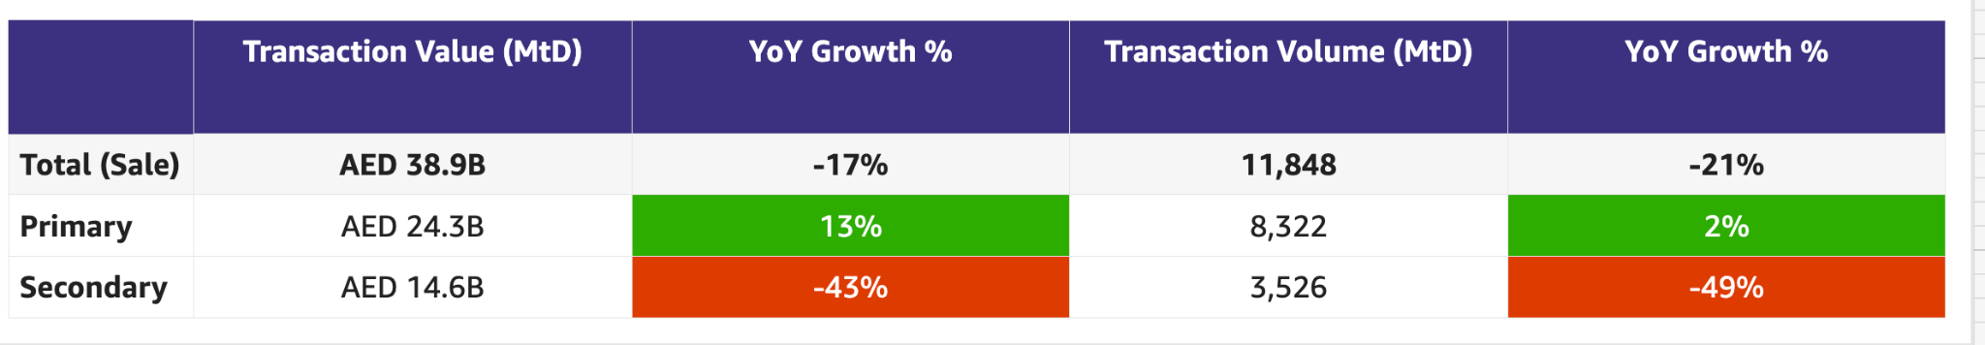

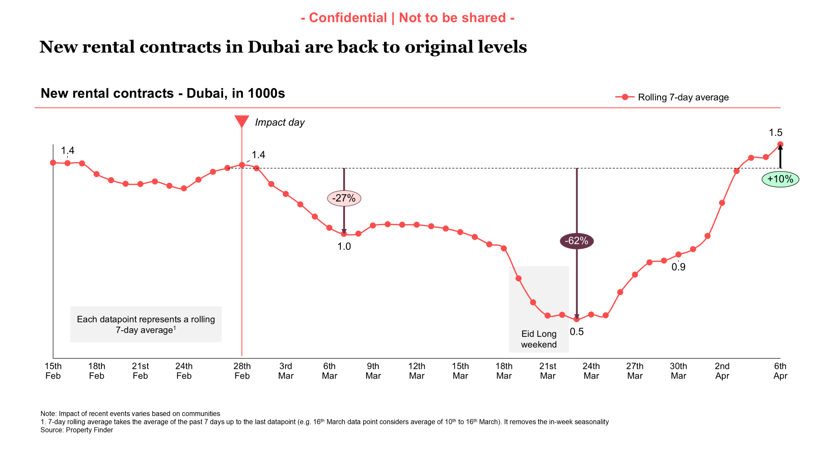

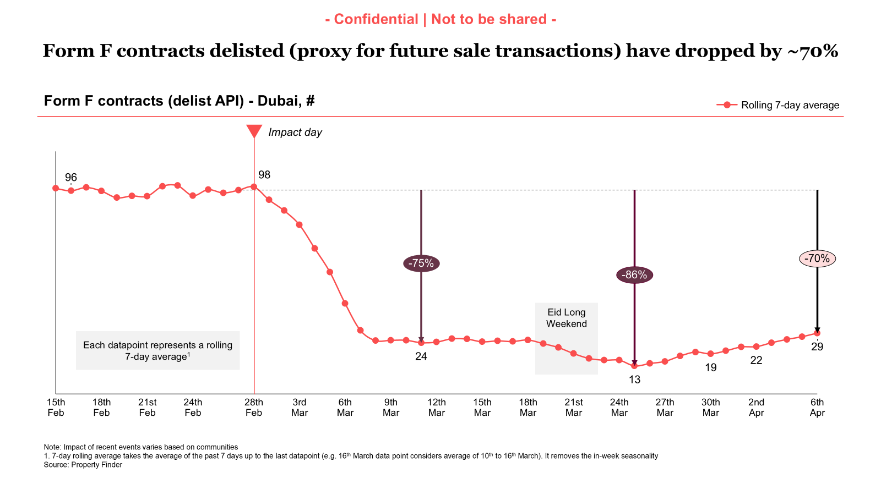

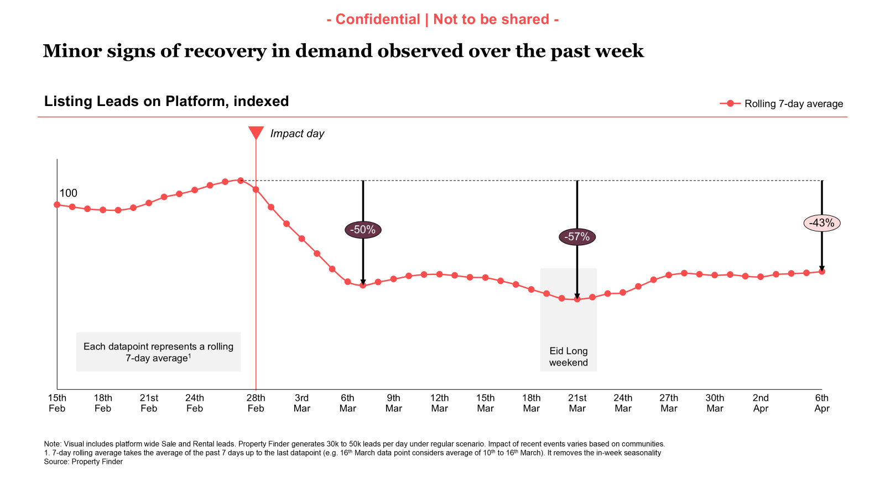
Rent: -38%
Sale: -52%
Primary: -60%
Secondary: -50%

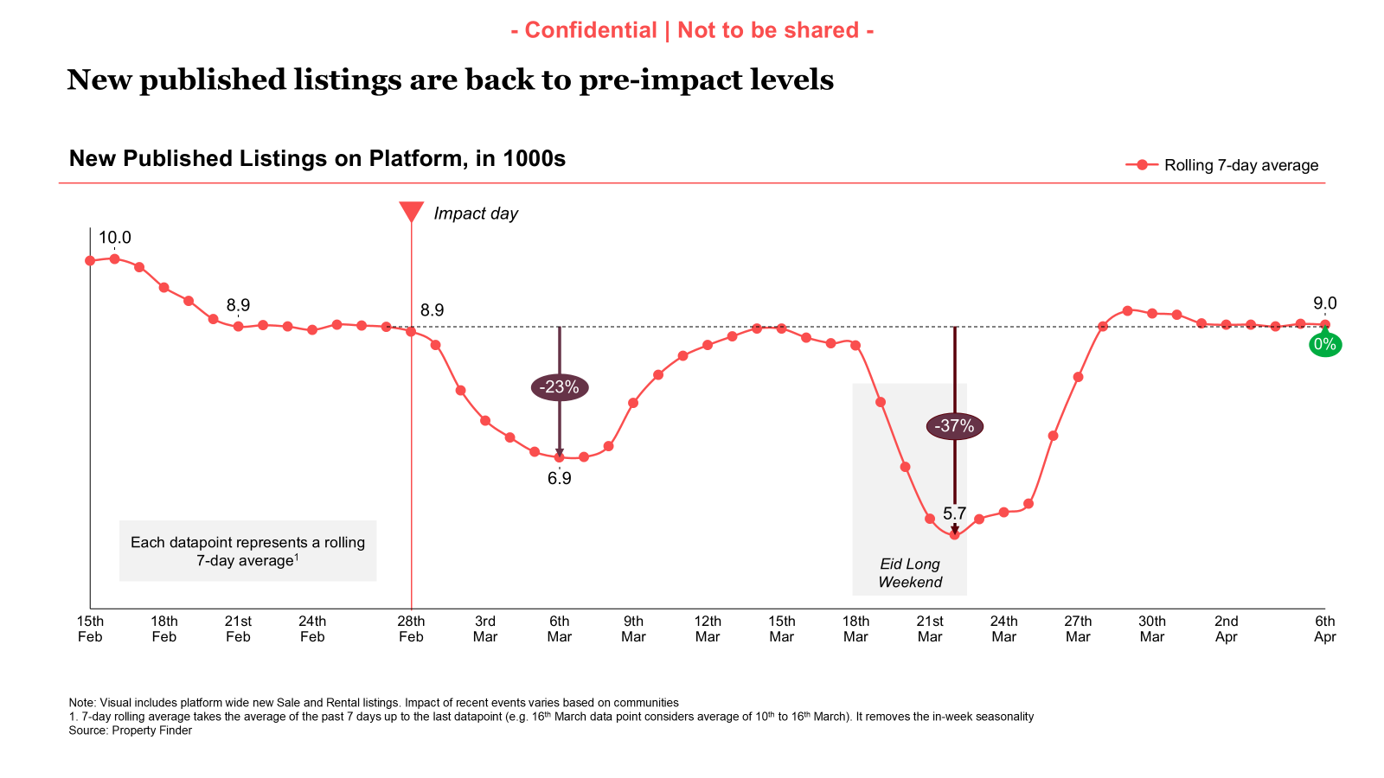

Commercial

Commercial
Category | DRI | Which metric is red and why | Actions planned | ETA for target achievement
Sales forecast % | Vladimir Malugin | March landed at 62% (volume retention 64%)  April FC value at 53% (with upside to 55%)  volume retention at 75% (with upside to 85%)  Continuation of hostilities is resulting in more downside, increase in churn and challenging upside. Concerns around cashflow for next few months are still top of client minds | Continued focus through following initiatives, while recognizing key risks:  - Account Plans  - Renewal Narratives  MITIGATION:  - New Eid Relief packages - announced yesterday at Commercial Townhall - solid EDGE offers  - Eid Relief packages - announced in March and in action, 79% of volume (~93% of the value) of book in active conversations  - Anti-crisis broker playbook - shared with BC:  - Leads and deals are not gone - there is less  - Time to nurture them more to close in 2-3 months  - If you are not in the market - you are not competing for sellers and buyers that are here
Exclusive Listings | Michelle Brackley | The recent scraping challenges by vendors have impacted last week’s Bayut listing count, particularly for Sale.  The BA team is working with them to resolve it and next week onwards we should be able to close it out.  The commercial team can still make progress with the CLEL list we have, and we’re taking actions already on it.  We analysed potential loss of listings by taking customers offline on 5th April:  Total listings:  - Potential loss of ~8% platform listings.  CLEL:  - Potential loss 11% of PF CLEL,  - 10% of common listings, these would become Bayut CLEL as the client already have these on Bayut  Whilst these numbers can look alarming, some of these will pay between now and 5th April and for others it will prompt them to become back into good standing to be able to list with us again  Uniqueness:  Non-paying clients:  28K total listings  Of which 20K in Dubai  These client represent 11,911 unique properties (T-IDs), of which 8,080 lies ONLY with them, and no one else on PF has it  We are assessing the actual numbers and will feed back. | - Increased relief offers for customers that have all Bayut listings on PF (Milestone driven benefits)  - Automatic import of BY Exclusive Listings  Owners: Hugs  Going live 6th April for all customers  - CPL discount on BY Exclusive listings  Owner: Anirudh  Next steps: focus on 11 rent communities we are losing share of sessions and SEO due to listing numbers. CSPs to drive conversations.  - Potential of additional credits to trial listing in certain communities  - Community ranking Methodology  Owners: Yash/Volkan  Next Steps: Exclusive listings will be incorporated into the ranking methodology for "Top Communities"  ETA: 06/04/2026  - Compass & data narrative:  Owner: Aksinia  Next steps: Design and content agreed on, now being built  ETA: 10/04/26  - Non-compliant listings:  Alignment on communication flow.  Implementation being planned  Lina and engineering to meet to understand timelines and process fully.  Implementation to start  ETA: 03/04/26

Weekly Metrics
 |  | Weekly |  |  |  | MTD (Apr)
Category | Metric | Week  (Actual) | Week (Target) | WoW | vs 2 weeks prior | MtD  (Forecast) | Month (Target) | vs MtD  prev month (MoM) | vs MtD  prev year (YoY) | vs competition | DRI | Dash
Sales  (MtD) - UAE | Sales Forecast %  (Month-end) | Monthly -> |  |  |  | 32.8 M  (53%) | 61.6 M | Not Applicable | Not Applicable | Not Applicable | Vladimir Malugin | Link

CLEL to not be discussed in Q1, till baseline is defined and Product actions are in place

Note: Compliance checks run on Wednesday and Thursday. Data on exclusive listings will be added on Friday

Category | Metric | Week  (Actual) | Week (Target) | WoW | vs 2 weeks prior | MtD  (Actual) | Month  (Target) | vs MtD  prev month (MoM) | vs MtD  prev year (YoY) | vs competition | DRI | Dash
Net exclusive listings | Rent | NA | NA |  |  | NA | NA | NA | NA | Not Applicable | Michelle Brackley
 | Sale | NA | NA |  |  | NA | NA | NA | NA | Not Applicable | Michelle Brackley
Supply | Net Exclusive Listings | NA | NA |  |  | NA |  | NA | NA | Not Applicable | Michelle Brackley
Supply |  | NA |  |  |  |  |  |  |  |  | Person

Total Listings

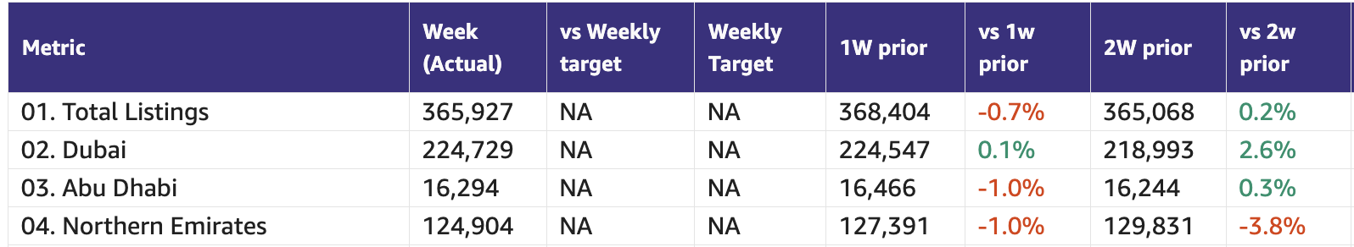

Primary (NP, Media, Dev)

Primary (New Projects, Media Sales)
Category | DRI | Which metric is red and why | Actions planned | ETA for target achievement
New Projects | Enguerran Milhiet | - Similar narrative as previous weeks in March: resilience:  - Demand (sessions and sold leads) in red, due to the conflict  - Gross revenue above target (pricing growing due to competition within clients). | - Similar to previous weeks: we continue to deliver on our roadmap.  - Importance of commercial support to drive adoption of two initiatives that will further improve conversion: Smart Leads and Open Leads v3. | March achievement  - Sessions: 60%  - Sold leads: 83%  - Revenue (net): 91%
Media & Developers | Sami Awada | N/A (will cover in monthly review) | N/A (will cover in monthly review) | N/A (will cover in monthly review)

Category | Metric | Week  (Actual) | Week (Target) | WoW | vs 2 weeks prior | MtD  (Actual) | vs MtD  prev month (MoM) | vs MtD  prev year (YoY) | vs competition | DRI | Dash
New Projects | Sessions | 55.5K | 87k | (+9.9%) | (-5.8%) | 211.9K | (-32.6%) | (-47.4%) |  | Enguerran Milhiet
 | Sold Leads | 1,774 | 1,787 | (+36.3%) | (+17.6% | 5782 | (-25.2%) | (+30.5%) |  | Enguerran Milhiet
 | Gross Revenue (USD) | $168.9K | $130.6k | (+45.4%) | (+25.9%) | 542.5K | (-23.3%) | (+47.9%) |  | Enguerran Milhiet
Media & Developer | Revenue from Media Products | NA | NA | NA | NA | Monthly |  |  |  | Sami Awada

Demand (Paid/Unpaid)

Demand
Category | DRI | Which metric is red and why | Actions planned | ETA for target achievement
Paid | Ahmed Osman | - All Metrics are down dueg to the conflict. | Summary (7 Apr 2026):  Demand: Sessions are recovering slowly but the more concerning trend is conversion rate. The gap between sessions and leads is widening week over week — we are generating traffic but fewer of those visits are converting into leads. This is a macro-driven behavioral shift, not a channel or bidding issue. Buy and investment intent is suppressing: consumers are pausing capital commitment decisions in the current environment. Rental intent is holding up materially better, which is expected — people continue to need housing and renew leases regardless of uncertainty. This distinction between rent and buy intent is shaping every allocation decision in April.  Spend: Google Search spend is running significantly above pre-conflict levels, reflecting the competitive battle. Meta spend has nearly doubled since late March and is continuing to scale. The mix is shifting deliberately toward paid social.  Leads: Paid leads are declining faster than sessions week over week, and CPL on search has risen sharply over the past week. Both trends confirm the conversion rate pressure described above.  Competitive — Bayut escalation and our position:  Bayut has continued to push since March 27 with the clear intent of dominating top position across most auction categories and forcing competitors to either match their bids or concede ground. On Core Rent, we are holding a strong and consistent lead — this is where we are investing aggressively, and the position reflects that. On Core Buy, Bayut has made a meaningful move in the last 48 hours, pushing their Absolute Top-of-Page rate significantly higher while ours pulled back. This is a new development we are assessing now.  Actions taken this week:  On paid search, we held Core Buy at a deliberate maintenance level given the declining conversion rate environment. Paying to defend position in an auction where conversion is suppressing is not the right use of budget right now. Core Rent investment is unchanged and we are defending that category aggressively.  On paid social, we have nearly doubled Meta spend since late March. The strategic reason: paid social builds our audience before users enter the Google Search auction, where Bayut is most active. We grow the retargeting pool on our own terms, convert at lower CPL, and reduce our dependence on an auction that is becoming increasingly expensive.  On programmatic display, Criteo and RTB House are being reactivated gradually to strengthen the retargeting layer as the Meta-driven audience pool grows.  Next Steps:  Three priorities for the remainder of April: continue scaling paid social to build audience depth and offset search conversion pressure; maintain aggressive investment in Core Rent where consumer intent is strongest; and make a go/no-go decision on Core Buy step-up based on this week's weekday auction data. We can reclaim Core Buy SOV within 24 hours when the conversion environment justifies it. | - N/A
Unpaid - SEO | Mahmoud Nessim | - SoV Vo2 is being worked on  - Sessions are recovering 18% WoW, still 30% behind the pre-sat target for March, the WoW increase is mainly driven by “Buy” while rent continues to have an overall market demand decline. | - Better tracking a good, reliable, scalable competitive metric ( Enhanced SoV )  - Shipping the footer content with data points to address the data related queries  - Building the revamped area insights to capture the demand around the price insights related keywords,  - Finalize the UGC placements + The Agents Q&A | - Finalize the Vo2 SOV keywords by Mid April.
Unpaid - Overall | Soumar Aoun | We are significantly underperforming vs targets, driven by both a traffic gap and a sharp decline in conversion, with Leads down materially more than Sessions — signaling that conversion is the primary issue, not just acquisition. While we are seeing WoW recovery across most metrics, performance remains well below MTD targets, with Web (especially SEO and Paid) being the largest contributor to the decline. Encouragingly, Direct traffic remains healthy with strong conversion, indicating that high-intent users still convert well, and the core issue lies in mid/low-intent journeys and experience quality.  - Sessions: -22% vs target (MTD -30%), slight WoW recovery  - Leads: -37% vs target (MTD -45%), declining faster than Sessions  - Conversion: -2.9pp vs target → main driver of underperformance  - Web: biggest drag (SEO -30%, Paid -19%, CVR down across both)  - App: traffic relatively resilient, but conversion sharply down (-4.7pp)  - Direct: strongest channel (CVR above target) → product works for high intent users | This week:  Ramping up (experiments → scale)  - CRM  - Saved Search notifications  - Saved Listing notifications  - Exposure-biased listings in Search re-engagement & Saved Search emails  - Homepage  - App Homepage (iOS) – 100%  - Web Homepage Revamp – 100%  Shipping this week (structural impact)  - Spam Workstream  - WAF token rollout (iOS & Android) — 02/04  Delayed / shifted  - Homepage (Android)  - App Homepage delayed due to blocker bugs identified in mobile testing  - Mitigation: adding additional resource to accelerate release readiness | - This week
Exposure LPL | Paresh Goyal | Note: Comparisons below are made vs prev. MTD (pre-geopolitical impact) rather than targets, as Q1 targets are not fully reflective of current market conditions.  - Rent  - Rent eLPL decline (-42%) is broadly in line with overall platform LPL decline (-46%), primarily driven by a sharp drop in leads (-43%), while listings have remained largely flat (minor decline,-2%).  - Buy  - Buy eLPL decline (-43%) vs prev. month is broadly in line with overall platform LPL decline (-51%), primarily driven by a sharp drop in leads (-54%) | - CRM: Search re-engagement email and the saved search emails with bias towards exposure listings went live on Apr 1.  - Expected Impact: CRM initiatives should help exposure leads from these activities to get back to pre-war levels  - Search reengagement  - 685 leads per send pre-war  - ~200 exposure leads per send  - 405 leads per send post war  - ~115 exposure leads per send  - With CRM changes, expected exposure leads per send of ~180  - Saved Search  - 1,773 leads per send pre-war  - ~480 exposure leads per send  - ~1040 leads per send post war  - ~280 exposure leads per send  - With CRM changes, expected exposure leads per send of ~470  - eLPL to be removed as a company OKR for Q2 and hence, no updated target revision to be carried out as previously planned for Q2

1. Share of Sessions

Platform | This week | March target | March target | Last week | vs last week | 2 weeks | vs 2 weeks | MTD | Last month | vs last month | Last year | vs last year
Total | 53.4% | 53.9% | 53.9% | 52.6% | 0.8 | 49.9% | 3.4 | 51.3% | 53.7% | -2.4 | 56.0% | -4.7
Web | 46.1% | 50.0% | 50.0% | 45.2% | 0.9 | 48.3% | -2.2 | 47.3% | 50.8% | -3.5 | 53.3% | -6.0
App | 58.0% | 55.9% | 55.9% | 57.4% | 0.6 | 51.0% | 7.0 | 54.0% | 56.4% | -2.4 | 59.2% | -5.2

App
Device category | This week | March target | Last week | vs last week | 2 weeks | vs 2 weeks | MTD | Last month | vs last month | Last year | vs last year
IOS | 55.5% | N/A | 54.7% | 0.8 | 48.5% | 7.0 | 51.8% | 54.1% | -2.3 | 51.9% | -0.2
Android | 59.7% | N/A | 59.3% | 0.4 | 52.6% | 7.1 | 55.5% | 57.9% | -2.4 | 63.6% | -8.1

Share of App DAU
Device category | This week | March target | Last week | vs last week | 2 weeks | vs 2 weeks | MTD | Last month | vs last month | Last year | vs last year
App (Total) | 58.7% | N/A | 57.3% | 1.4 | 51.8% | 6.9 | 51.6% | 57.9% | -6.2 | 54.3% | -2.7
IOS | 55.3% | N/A | 54.1% | 1.3 | 48.6% | 6.7 | 48.5% | 54.6% | -6.1 | 46.9% | 1.6
Android | 60.8% | N/A | 59.3% | 1.4 | 53.8% | 6.9 | 53.6% | 59.9% | -6.3 | 58.6% | -5.0

3. Demand Funnel (Cheq implemented in Apr-25 )
Total

Web-Paid

Web–SEO (SEO blog sessions are not included)

Web-Direct

App-Total

Exposure LPL

Category | Metric | Week  (Actual) | Week (Target) | WoW | vs 2 weeks prior | MtD  (Actual) | Month  (Target) | vs MtD  prev month (MoM) | vs MtD  prev year (YoY)
Exposure LPL (scaled to 30 days) | Rent | 8.5 | (-22.7%)  11.0 | (+19.7%)  7.1 | (-5.6%)  9.0 | 8.0 | (-27.3%)  11.0 | (-38.0%)  12.9 | (-32.2%)  11.8
 | Sale | 4.7 | (-38.2%)  7.6 | (+27.0%)  3.7 | (-6.0%)  5.0 | 4.4 | (-42.1%)  7.6 | (-42.9%)  7.7 | (-46.3%)  8.2

Rent/Buy leads
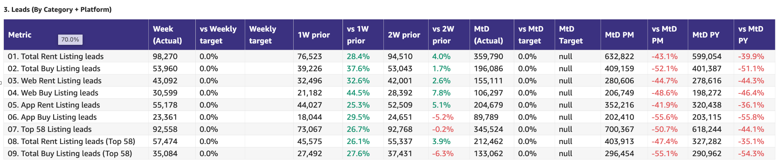

Leads and listings distribution

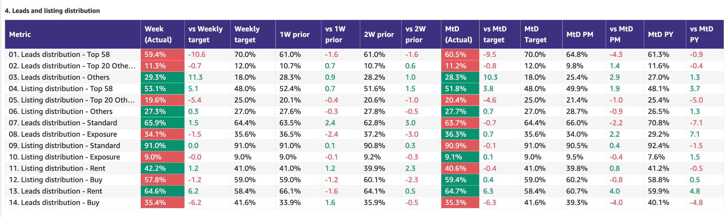

Monthly Metrics

B2C NPS
Category | Metric | MtD  (Actual) | Month (Target) | vs MtD  prev month (MoM) | vs MtD  prev year (YoY) | vs competition | DRI | Dash
B2C NPS | B2C NPS | 10 | Not Available | 4 | 11 | Not Available | Alson Dsouza

Leads click to delivered (monthly metric):
Category | Metric | MtD  (Actual) | Month (Target) | vs MtD  prev month (MoM) | vs MtD  prev year (YoY) | Δ vs Competition | DRI | Dash
Leads Funnel | Total Leads Delivered (WA) |  |  |  |  | Not Available | Soumar AounSruthi Poduval | Link
 | % Clicks to Delivered (WA) |  |  |  |  | Not Available | Soumar AounSruthi Poduval | Link
 | Error Leads (WA) |  |  |  |  | Not Available | Soumar AounSruthi Poduval | Link

PR Metric
Category | Metric | MtD  (Actual) | Month (Target) | vs MtD  prev month (MoM) | vs MtD  prev year (YoY) | vs competition | DRI | Dash
PR | PR Sov | 100% | 50-55% |  | [...] | [...] | Natalie Faulkner | PR team

- Competition
  - Share of Session (Overall, Web Channels, App Channels)
  - SoV - Paid click share

- Demand Funnel
  - Sessions (by channels)
  - Leads (by channels)
  - CR (by channels)
  - Click to Delivered

- Exposure LPL
  - Overall / Rent / Sale
  - Top Communities
  - Web/App
  - Exposure Leads as % of Total Leads (Overall / rent / sale)
  - Exposure Listings (Overall / rent / sale)

- Engagement Metric (Time on site)
- PR SoV - We remain firmly in green as we are endorsed by wider conversations from investors, such as Mubadala - this is the perfect storytelling endorsement, when 3rd parties talk about how important we are to the UAE ecosystem
- Leads split by Rent vs Buy

Data Governance

DATA GOVERNANCE
Problem Name | Problem Description | Latest update | Resolution update (ETA) | DRI
App:  Kochava vs Redshift | Sessions, leads, installs and users in Reshift do not match the same in Kochava | UAE  Session & leads - fixed  Users & installs - fixed  Int  Session & leads - under investigation  Users & installs - under investigation | n/a | DE: Uday Kasetty  BA: Xueshan Zou
Web:  GA4 vs Redshift | Sessions and leads channel breakdown in Redshift not matching GA4  Users in Redshift not matching GA4 | UAE - fixed  Int - fixed | n/a | DE: Aamir Shaiq  BA: Mohamed Hamed
CRM Attribution Reporting | Braze traffic not matching Kochava for Android | Push notifications  - iOS - fixed  - Android - solution implemented  Email campaigns - not started (pending Android fix)  WA campaigns - not started (pending Android fix) | n/a | B2C: Abdullah Shah  MarTech: Wael Abdella

B2C App Engagement

B2C App
Category | DRI | Which metric is red and why | Actions planned | ETA for target achievement
App engagement & installs | Ahmed Osman | - N/A. Green | - Scaling App acquisition further. Focus is on Android.  - Current Rankings (AE-Google Play) as of 7th of April:  - Bayut: 87 (WoW +5)  - Property Finder: 184 (WoW +48)
App ratings | Soumar Aoun | - We are significantly underperforming vs targets driven by:  - 1. 1-star/2star going up (contributing 70% of decline) and google removal 5 star of rating (18%)  2. In-app rating also follows similar trend (rating in the range of 2-3 star)  3. Marketing campaign disproved as cause of the rating  4. Review analysis reveals optimization for agent experience (~46% reviews), listings (~27%) as opportunity to improve  5. Two app versions (13.44.0 and 13.45.1 ) seem to be the cause of the issue. No tracking available for BA.  (for 100 1 star rating, we need to add 720 5 star rating to come back to the same level ) | - We are seeing massive fluctuations in Android ratings and are evaluating the cause (more than 1.2pps) change within days.  - We have 3 actions planned:  - Randomize in-app solicitation to make sure we don’t get less ratings  - 79% of the reviews are specific to agents & listings - identify a mechanism to connect agent feedback and in-app user ratings  - B2B+B2C work on a single product to capture closure moments and help get ratings on app and agents profile | - Planned in Q2 - based on BW re-calibration

Weekly Metrics -
App ratings

 |  | Weekly |  |  |  | MTD
Category | Metric | Week  (Actual) | Week (Target) | WoW | vs 2 weeks prior | MtD | Month (Target) | vs MtD  prev month (MoM) | vs MtD  prev year (YoY) | vs competition | DRI
B2C App | DAU | 54.4K |  | (+5.0%)  51.8K | (+4.8%)  51.9K | 50.3K |  | (-18.9%)  62.0K | (-4.9%)  52.9K |  | Sanidhya Nanavati
B2C App | WAU | 204.4K |  | (+4.1%)  196.4K | (+9.5%)  186.6K | 195.0K |  | (-13.7%)  225.9K | (-1.1%)  197.2K |  | Sanidhya Nanavati
B2C App | MAU | 429.4K |  | (-2.1%)  438.8K | (-4.0%)  447.1K | 445.3K |  | (-5.5%)  471.2K | (-5.0%)  468.8K |  | Sanidhya Nanavati

App Rankings

Device Category | Ranking Category | Company Name | Ranking | 1W prior | Vs 1W prior | 2W prior | Vs 2W prior
Android | Overall | Bayut | NA | 120 | NA | NA | NA
 |  | Property Finder | NA | NA | NA | NA | NA
iOS | Overall | Bayut | 82 | 87 | ⬇ 5 | NA | NA
 |  | Property Finder | 99 | 89 | ⬇ 10 | NA | NA
Android | House and Home | Bayut | 47 | 1 | ⬇ 46 |  | 0
 |  | Property Finder | 51 | 2 | ⬇ 49 |  | 0
iOS | Lifestyle | Bayut | 4 | 3 | ⬇ 1 | 8 | ⬇ 2
 |  | Property Finder | 7 | 4 | ⬇ 3 | 5 | ⬆ 1

- App Installs
- App MAU
- App DAU
- App WAU
- Android Playstore ranking (Overall and in specific category) vs Bayut
- iOS Appstore ranking (Overall and in specific category)
- DAU/MAU
- Sessions / DAU
- Login Ratio
- Avg Session Duration
- Playstore rating (Android)
- Playstore rating (iOS)

B2C Tech Metrics

B2C App
Category | DRI | Which metric is red and why | Actions planned | ETA for target achievement
App stability & performance | Taran Kambow | NA | Continuous Performance Uplevelling
Web Stability & Performance | Amory Kelie | Mobile INP Good Rate is 75.0%, exceeding both weekly and monthly targets.  The improvement is driven by broad-based performance gains across all major templates, with strongest impact from Search Landing Pages and Property Listing Pages, which together represent the majority of user interactions.  Interaction latency has reduced consistently across high-traffic surfaces, and previously volatile segments such as “Other” have also stabilized.  The metric is now consistently above target and operating at a structurally improved performance level. | • Sustain performance through enforced guardrails on high-traffic templates  • Extend performance budgets and monitoring across all templates  • Continue governance on experiments, feature flags, and third-party scripts  • Maintain daily monitoring to prevent regressions  • Identify next optimization opportunities to drive performance beyond 75% | - Q2 target (75%) achieved ahead of plan  - Focus now on maintaining ≥75% and driving further improvements

 |  | Weekly |  |  |  | MTD
Category | Metric | Week  (Actual) | Week (Target) | WoW | vs 2 weeks prior | MtD  (Forecast) | Month (Target) | vs MtD  prev month (MoM) | vs MtD  prev year (YoY) | vs competition | DRI | Dash
Tech stability & Performance | Mobile INP Good rate (%) | 75.0 | 73 | +2.5 | +3 |  | 75 |  |  |  | Amory Kelie

- Appdex: Android
- Appdex score: iOS
- CWV

B2B Product

B2B
Category | DRI | Which metric is red and why | Actions planned | ETA for target achievement
CSAT  (Incident Volume) | Luis Cappa | Metric in green | 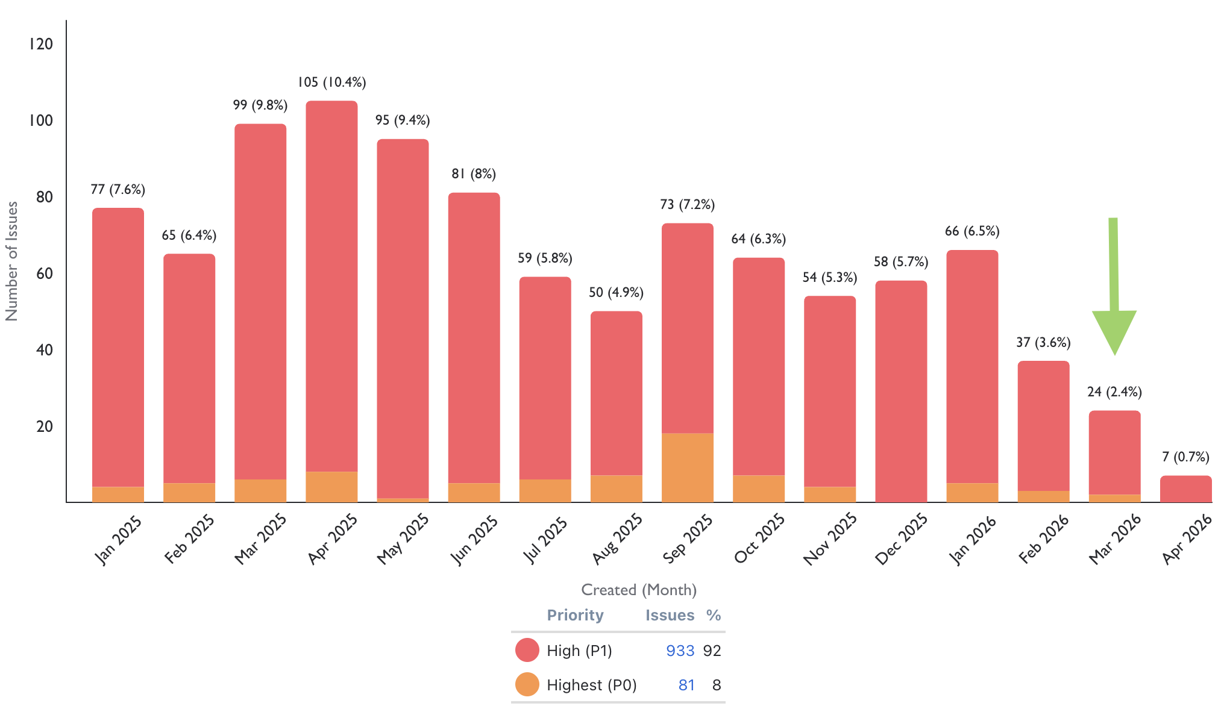
Agent Experience | Sajjad Ahmad | - 140 new users acquired.  - +16% recovery on WAU since last 2 weeks | - | End of April

Weekly Metrics
 |  | MTD
Category | Metric | MtD  (Actual) | Month (Target) | vs MtD  prev month (MoM) | vs MtD  prev year (YoY) | vs competition | DRI | Dash
CSAT | Incident Volume | P0: 2  P1: 22 | P0: 6  P1: 73 | P0: 3  P1: 34 | P0: 6  P1: 90 | Not Available | Luis Cappa | Link  (JIRA)

 |  | Weekly |  |  |  | MTD
Category | Metric | Week  (Actual) | Week (Target) | WoW | vs 2 weeks prior | MtD  (Actual) | Month (Target) | vs MtD  prev month (MoM) | vs MtD  prev year (YoY) | vs competition | DRI | Dash

Agent Engagement & Experience | App active agents | 11,601 | (-22.6%)  14,997 | (+1.3%)  11452 | (+2.3%)  11341 |  |  |  | Not Available | Not Available | Sajjad Ahmad | TBA
 | Active users per week (WAU) | 3197 | (-41.9%)  5,500 | (+16.0%)  2755 | (-0.2%)  3203 |  |  |  | Not Available | Not Available | Sajjad Ahmad | TBA
 | Agent NPS | NA | NA | NA | NA | Monthly Metric |  |  |  |  | Sajjad Ahmad | TBA

Agent Engagement & Experience | Agent NPS | Monthly Metric |  |  |  |  | Sajjad Ahmad

Listing Quality

Monetization
Category | DRI | Which metric is red and why | Actions planned | ETA for target achievement
Compliance | Saif Al-Amid | - New metric/sub metrics are to be automated from next week | - So far we have flagged 18K listings (9k corrected by agent, 9k deleted) out of nightly automation/batches.  - Permit Locations mandation is also released this week and we have so far flagged ~2.5k listings so far.  - We have Permit Size mandation dev ready this week.  - Prevention of republication is also dev ready.  - However we are re-visiting the initiatives timelines in light of the recent redundancies as there are dependencies on CX and other teams.

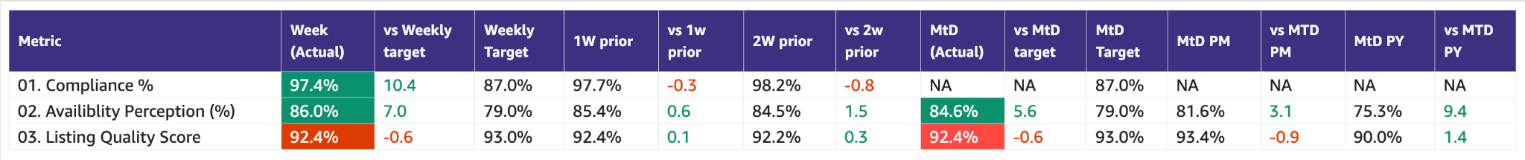

Special Projects
Monthly Lookbacks

Converting at risk clients to Promoters Ivan Gregorc Status
- Expected achievement at the end of the quarter. Based on current progress, what’s the estimated achievement rate for the end of Q1 2025?
By end of Q1, we expect to convert 50%+ of Neutral/Detractor clients into Promoters (target= 15 promoters) and protect renewal risk across the Marketing-owned portfolio (20 clients). Assuming delivery on Product-dependent items.
Current status: 🟢Promoters: 9 🟡Neutral: 9 🔴Detractors: 2
- Achievement (till date) : Indicate completed and pending tasks.
- Client sentiment baseline established and tracked weekly
- Identified top 6 elements to turn Neutral clients into promoters
- Active engagement in place for all Target clients
Pending:
- Impediments : If applicable, what is delaying the progress?
- The majority of blockers are Product-dependent
- Some perception issues (Awards, Premium value) require time and repetition to shift
- Initiatives to address impediments: What actions will we take to address the above issues or improve results?
- 5 out of the 6 (SuperAgent Point System, Spam Leads, Split Deals, Agent Engagements,, Cost of Premium Listings) major issues brought up are being addressed by end March
- 1 out of the 6 (Draft listings Listings) was addressed
Link to deep dive document

Special Projects - Q1 OKRs
Keyper Soumar Aoun On Track
- Expected achievement at the end of the quarter. Based on current progress, what’s the estimated achievement rate for the end of Q1 2025?
  - Keyper integration across B2B and B2C flows is in progress, with the majority of core components in active development and the remaining work focused on final CX workflow alignment and commercial enablement.
Core integration is on track for completion by the end of March. A buffer period for end-to-end testing and launch readiness will follow, with go-live expected no later than 15 April 2025 with overall progress reaching ~95% completion by the end of Q1 2025.
- Achievement (till date) : Indicate completed and pending tasks.
  - 3 agencies selected for MVP launch
  - ~50% of Keyper implementation delivered and the rest is under progress
  - The CX team is working towards a joint CX workflow plan with Keyper.
  - Legal review of key agreements within the flow is ongoing.
- Impediments : If applicable, what is delaying the progress?
  - Design and development capacity constraints have impacted the pace of the integration.

- Initiatives to address impediments: What actions will we take to address the above issues or improve results?
  - Additional contractors onboarded to the B2C team to increase capacity and accelerate delivery
  - Prioritization of core integration components to ensure critical functionality is delivered on schedule

Bundles Paresh Goyal On Track
- Expected achievement at the end of the quarter. Based on current progress, what’s the estimated achievement rate for the end of Q1 2025?
  - MVP Product will be ready for launch in March
  - Pilot sales has been intentionally pushed out, given current market and client situation
- Achievement (till date) : Indicate completed and pending tasks.
  - Development work progressing on-track but with some impact from salesforce migration
- Impediments : If applicable, what is delaying the progress?
  - Salesforce system has just come back online and hence, salesforce development work had paused
  - Expected impact of 2-3 days in completing salesforce development and hence, delay in go-live from 24th March to 26th March
- Initiatives to address impediments: What actions will we take to address the above issues or improve results?
  - Working towards an approach to sign paper contracts for bundles and a potential way to manually switch on bundles for such clients

📋 Prev Saved Reports

Week | Date | Link
Week 12 | Mar 16 to 22 | WBR - Week 12 (Saved Report) Metric Report
Week 11 | Mar 9 to 15 | WBR - Week 11 (Saved Report) Metric Report
Week 10 | Mar 2 to Mar 8 | WBR - Week 10 (Saved Report) Metric Report
Week 9 | Feb 1 to Feb 28 | WBR - Week 9 - Feb Monthly Lookback (Saved Report) Metric Report
Week 8 | Feb 16 to Feb 22 | WBR - Week 8 (Saved Report) Metric Report
Week 7 | Feb 9 to Feb 15 | WBR - Week 7 (SAVED) Metric Report
Week 6 | Feb 2 to Feb 8 | WBR - Week 6 (Saved) Metric Report
Week 5 | Jan 1 to Jan 31 | WBR - Jan Monthly Lookback (Saved Report) Metric Report
Week 4 | Jan 19 to Jan 25 | WBR - Week 4 (Saved) Metric Report
Week 3 | Jan 12 to Jan 18 | WBR - Week 3 (SAVED) Metric Report
Week 2 | Jan 5 to Jan 11 | WBR - Week 2 (SAVED) Metric Report
Year End.
W52 | Dec 1 to Dec 30 | WBR Metric Report - Dec Monthly Lookback (Saved Report)
W49 | Dec 1 to Dec 7 | WBR Metric Report - Week 49 (Saved Report)
W48 | Nov 1 to Nov 30 | WBR Metric Report - Week 48 - Nov Monthly Lookback (Saved Report)
W47 | Nov 17 to Nov 23 | WBR Metric Report - Week 47 (Saved Report)
W46 | Nov 10 to Nov 16 | WBR Metric Report - Week 46 (Saved Report)
W45 | Nov 3 to Nov 9 | WBR Metric Report - Week 45 (Saved Report)
W44 | NA | NA
W43 | Oct 1 to Oct 31 | WBR Metric Report - Week 43 - Oct Monthly Lookback (Saved Report))
W42 | Oct 15 to Oct 21 | WBR Metric Report - Week 42 (Saved Report)
W41 | Oct 8 to Oct 14 | WBR Metric Report - Week 41 (Saved Report)
W40 | Oct 1 to Oct 7 | WBR Metric Report - Week 40 (Saved Report)
W39 | Sep 1 to Sep 30 | WBR Metric Report - Week 39 (Saved Report)
W38 | Sep 17 to Sep 23 | WBR 2.0 Report - Week 38 (Saved Report)
W37 | Sep 10 to Sep 16 | WBR 2.0 Report - Week 37 (Saved Report)
W36 | Sep 3 to Sep 9 | WBR 2.0 Report - Week 36
W35 | Aug 1 to Aug 31 | Copy of WBR 2.0 Report - Week 35.docx
W34 | Aug 20 to Aug 26 | Copy of WBR 2.0 Report - Week 34.docx
W33 | Aug 13 to Aug 19 | WBR 2.0 Report - Week 33.docx
W32 | Aug 6 to Aug 12 | Copy of WBR 2.0 Report - Week 32.docx
W31 | Jul 30 to Aug 5 | WBR 2.0 Report - Week 31.docx

